**BAHRIA UNIVERSITY (KARACHI CAMPUS**)

**Computer Programming (CSC - 113)**

**Assignment 02**

**Fall 2022**

**Class: BSE 1B Shift: Morning**

**Course Instructor: MUHAMMAD FAISAL Submission: 4 Dec 2022**

**Date: 24 Nov 2022 Marks: 05 Points**

**Student Name: ABDULLAH Registration #: 02131222099**



**[CLO-3]**

Question No 1:Write a program that will use switch statements and calculate the salary of an employee by using the information like Allowances, Provident Fund etc.

Input:

using System;

namespace Abdullah_CP_Assignment_2

{

class Program

{

static void Main(string[] args)

{

string name;

int grade, bS;

double totalSalary;

Console.WriteLine("Please Enter Your Name:");

name = Console.ReadLine();

Console.WriteLine("Please Enter Your Basic salary:");

bS = Convert.ToInt32(Console.ReadLine());

Console.WriteLine("Please Enter Your Grade:");

grade = Convert.ToInt32(Console.ReadLine());

Console.Clear();

switch (grade)

{

case 17:

totalSalary = (bS + (0.05 * bS) + (0.025 * bS) + (0.01 * bS)) - (0.075 * bS);

Console.WriteLine("Mr. {0} your salary is Rs. {1}", name, totalSalary);

break;

case 18:

totalSalary = (bS + (0.055 * bS) + (0.03 * bS) + (0.015 * bS)) - (0.075 * bS);

Console.WriteLine("Mr. {0} your salary is Rs. {1}", name, totalSalary);

break;

case 19:

totalSalary = (bS + (0.06 * bS) + (0.033 * bS) + (0.015 * bS)) - (0.075 * bS);

Console.WriteLine("Mr. {0} your salary is Rs. {1}", name, totalSalary);

break;

default:

Console.WriteLine("Invalid Rank!");

break;

}

}

}

}

Output:

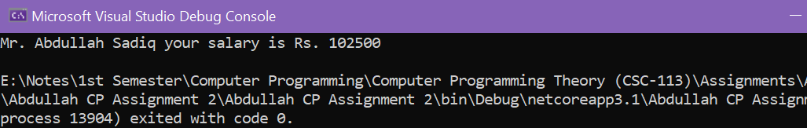

Question No 2: Multiply Array1 with Array2 and stores its result in Array3. Apply matrix rules for multiplication [Row N * Col N]. [Using loop]

Solution:

Input:

using System;

namespace Abdullah_CP_Assignment_2

{

class Program

{

static void Main(string[] args)

{

int[,] prod = new int[4, 3];

int[,] a =

{

{3,4,5},

{6,7,9},

{5,6,8},

{6,4,4}

};

int[,] b =

{

{6,4,2},

{5,2,3},

{7,6,4},

{4,7,8}

};

Console.Write("\na:");

for (int i = 0; i <= 3; i++)

{

Console.WriteLine("");

for (int c = 0; c <= 2; c++)

{

Console.Write("\t{0}", a[i, c]);

}

}

Console.WriteLine("");

Console.Write("\nb:");

for (int i = 0; i <= 3; i++)

{

Console.WriteLine("");

for (int c = 0; c <= 2; c++)

{

Console.Write("\t{0}", b[i, c]);

}

}

Console.WriteLine("");

Console.Write("\na x b:");

for (int i = 0; i <= 3; i++)

{

Console.WriteLine("");

for (int c = 0; c <= 2; c++)

{

prod[i, c] = a[i, c] * b[i, c];

Console.Write("\t{0}", prod[i, c]);

}

}

}

}

}

Output:

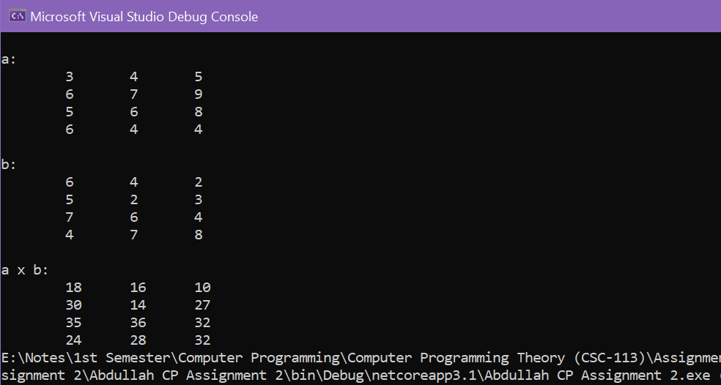

Question No 3: Write a program that will generate the monthly installment and total amount to be paid of personal loan where the insurance is 2% and mark up is 18% per year, initial processing fee is 3%.

Solution:

Input:

using System;

namespace Abdullah_CP_Assignment_2

{

class Program

{

static void Main(string[] args)

{

double loan, year;

Console.WriteLine("Please enter the Amount you want for Loan:");

loan = Convert.ToDouble(Console.ReadLine());

Console.WriteLine("For how many years you want the Amount:");

year = Convert.ToDouble(Console.ReadLine());

Console.Clear();

double ipFee = loan * 0.03;

double insurance = loan * 0.02;

double markUp = (loan * 0.18) * year;

double payableAmount = loan + insurance + markUp;

double months = year * 12;

double monthlyInstallment = payableAmount / months;

Console.WriteLine("\nAmount Taken: {0} \nMonthly Installment: {1}\nInitial Processing Fee: {2} (To be paid once at the time of Approval of Loan).\nInsurance Fee: {3} (2% of Loan)\nTotal ammount to pay after {4} year: {5} Rs.", loan, monthlyInstallment, ipFee, insurance, year, payableAmount);

}

}

}

Output:

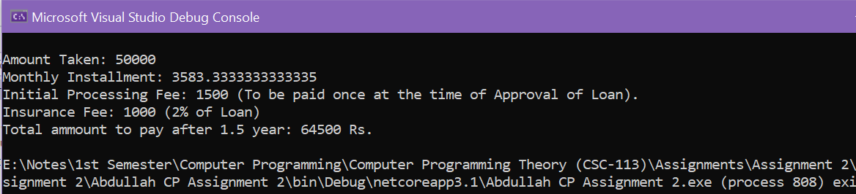

Question No 4: Write an Algorithm to generate total bill of an automobile shop, where the bill is divided into mechanical charges, vehicle parts charges, Auto wash charges and other charges for a customer if the total bill of mechanical charges and vehicle parts charges is over Rs. 10,000/- then the customer will get complementary car wash and car wash charges will be removed from the bill.

Solution:

**Step 1:** Start

**Step 2:** Take input from users about services (Vehicle part change, Mechanical work, Auto Wash etc.)

**Step 3:** Calculate the total charges regarding the services provided to users.

**Step 4:** Check that if the bill is Larger than 10,000 Rs. If yes, give that customer a

Complementary car wash and remove the car wash charges.

**Step 5:** Print the Total Billing Amount.

**Step 6:** Stop

Question No 5: Write a program that will generate the output (Given in Question).

Solution:

Input:

using System;

namespace Abdullah_CP_Assignment_2

{

class Program

{

static void Main(string[] args)

{

for (int i = 1; i <= 3; i++)

{

Console.WriteLine("\nChapter {0}\n",i);

for (int j =1;j<=5;j++)

{

Console.WriteLine("\tSection {0}.{1}",i,j);

}

}

}

}

}

Output:

